**Assignment 4 – Critical Thinking**

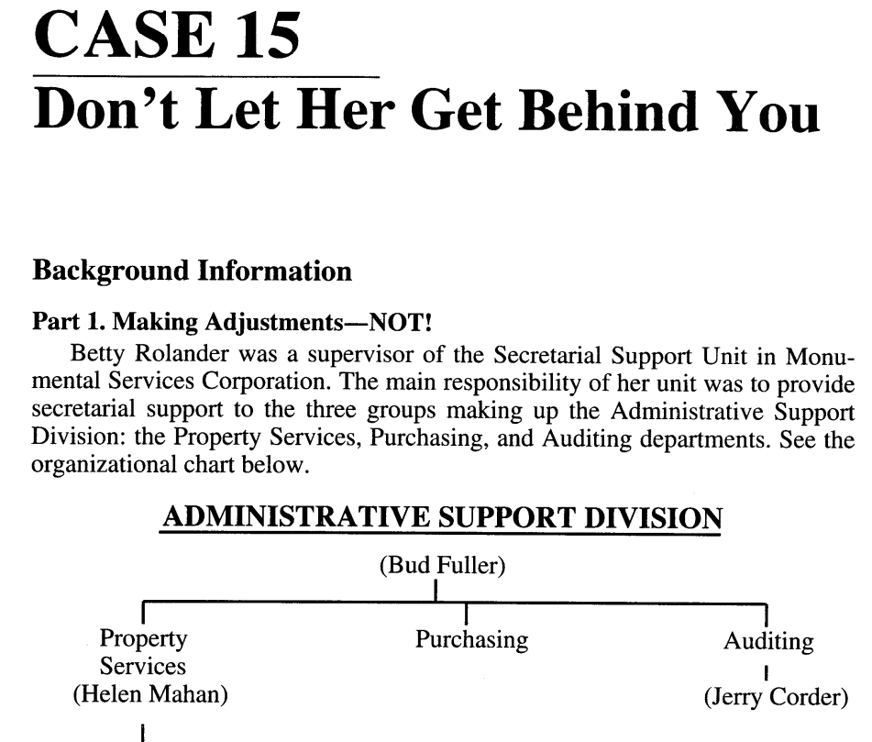

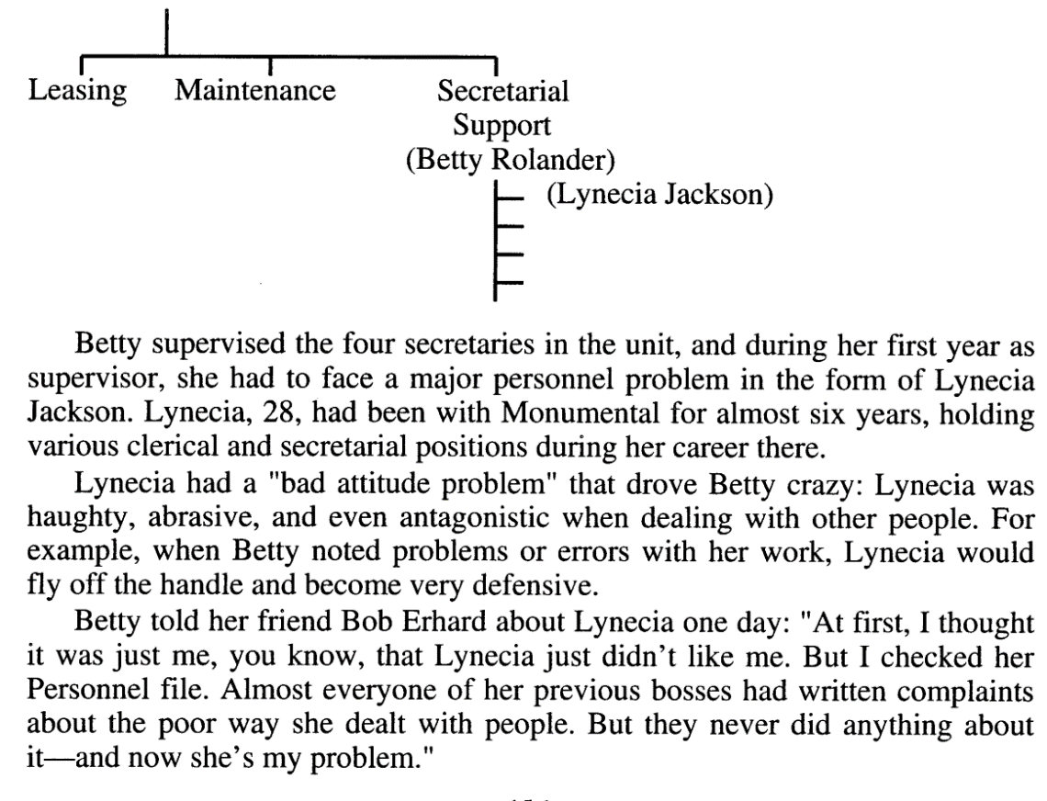

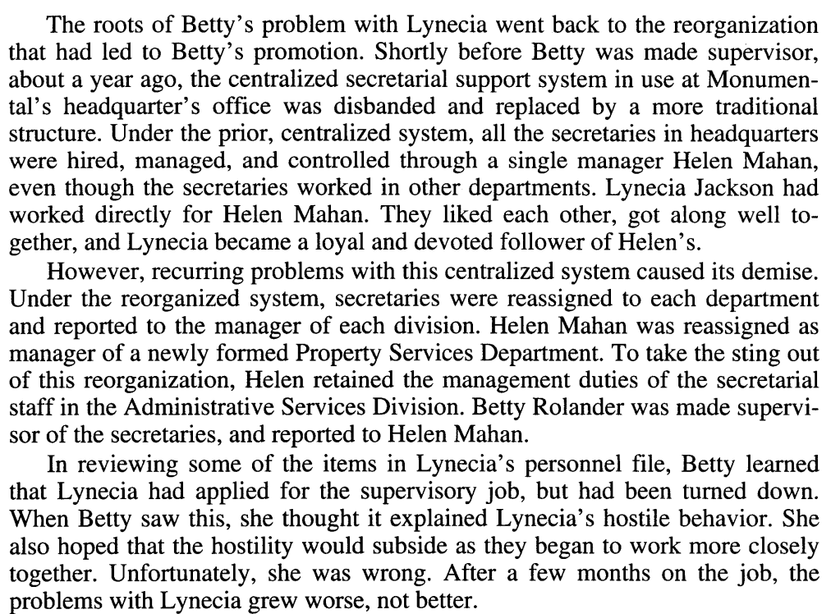

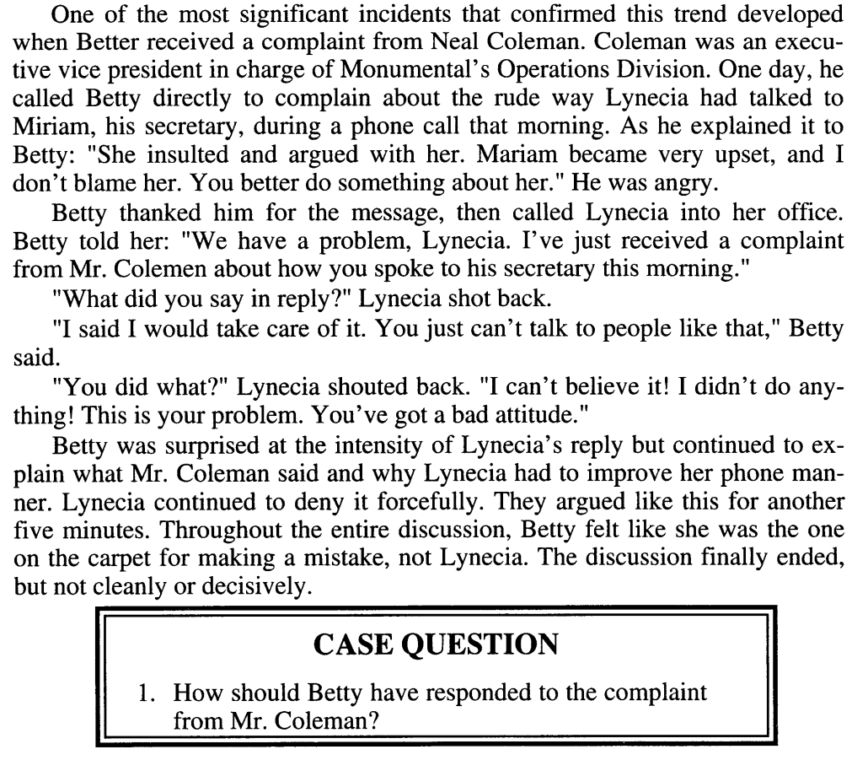

When betty received the complain from mr. coleman she feel very sad and

Betty said that I apologize for this mistake. I would talk to lynecia about this complain

And advice her to improve her phone manner. And next time this kind of shit will never happened.

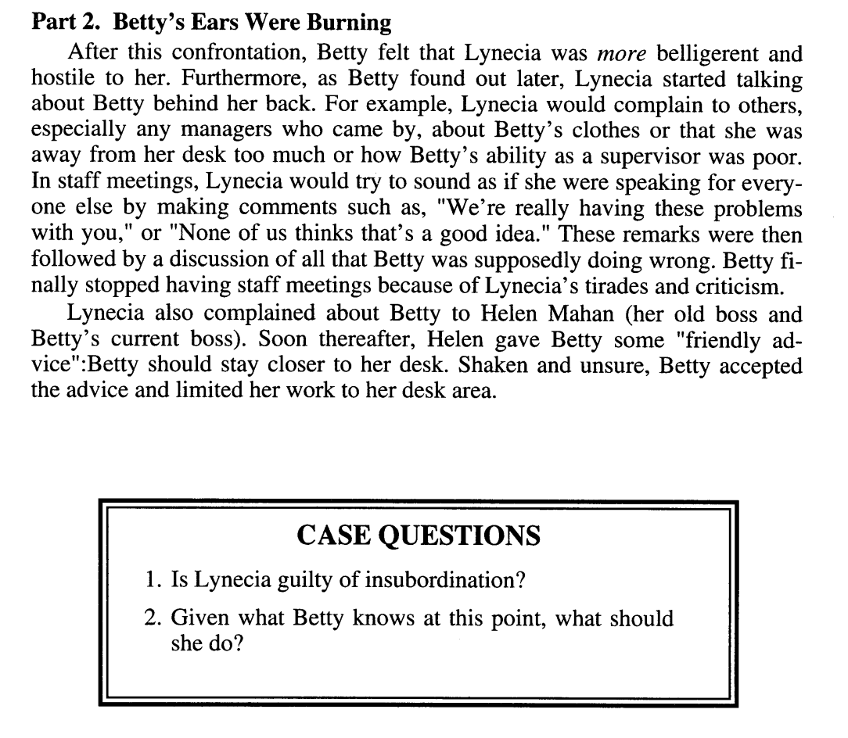

1: No because her behavior was so bad with everyone especially with betty . So, she did not care about what she doing.

2: she would follow the advice given from the Helen and In my opinion Helen would give lynecia a little opportunity of supervisor of any kind of department so that I think it would make lynecia behavior better. Thank you ☺